**CDAC Mumbai PG-DAC August 24**

**Assignment No- 4**

1. Write a program that demonstrates widening conversion from int to double and prints the result.

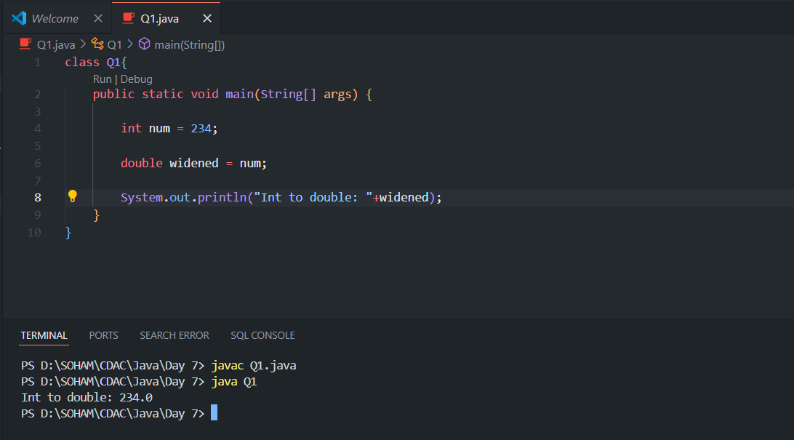

1. Create a program that demonstrates narrowing conversion from double to int and prints the result.

1. Write a program that performs arithmetic operations involving different data types (int, double, float) and observes how Java handles widening conversions automatically.

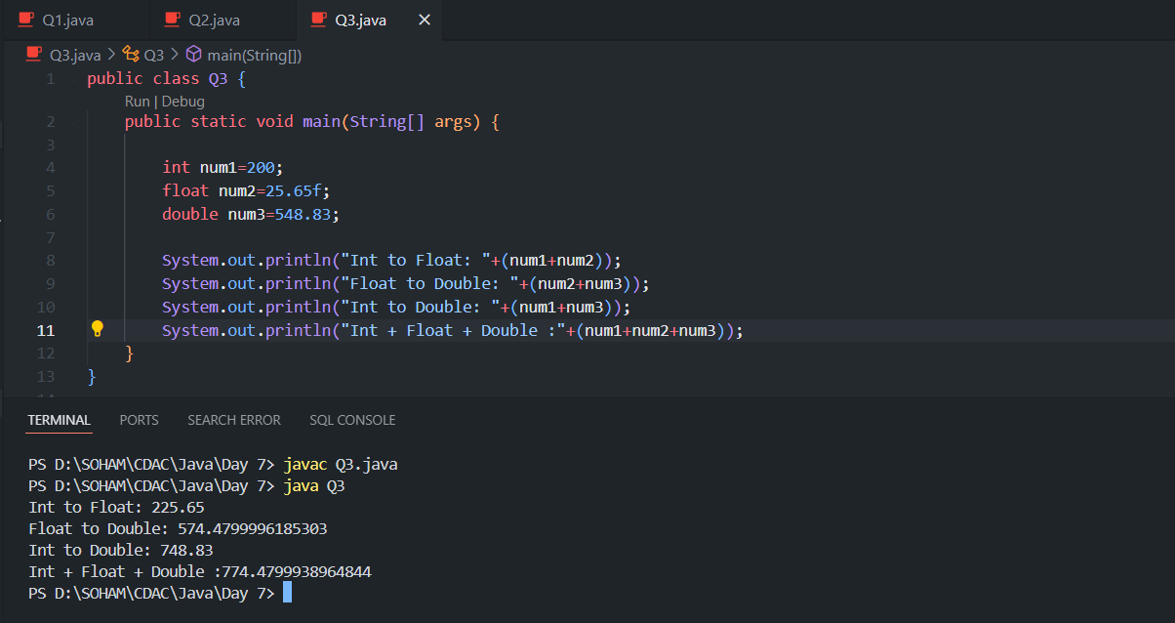

1. Write a Program that demonstrates widening conversion from int to (double, float, boolean, string) and prints the result.

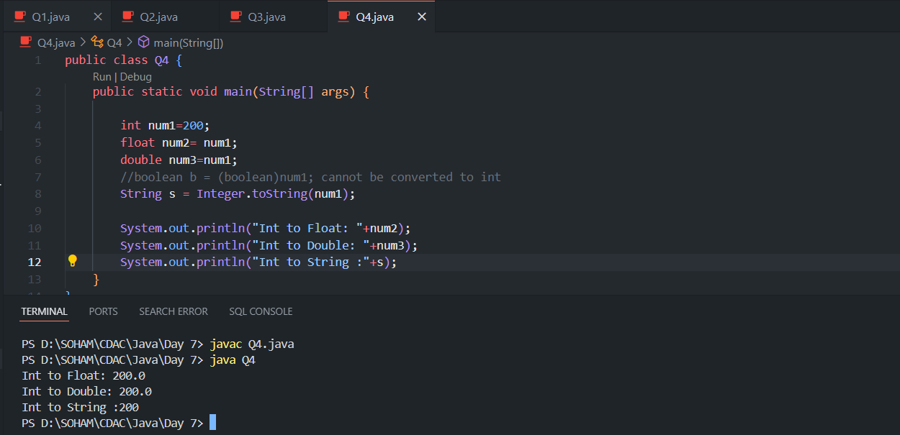

Interview Questions

1. What does the static keyword mean in Java? Explain the difference between static and non-static methods.

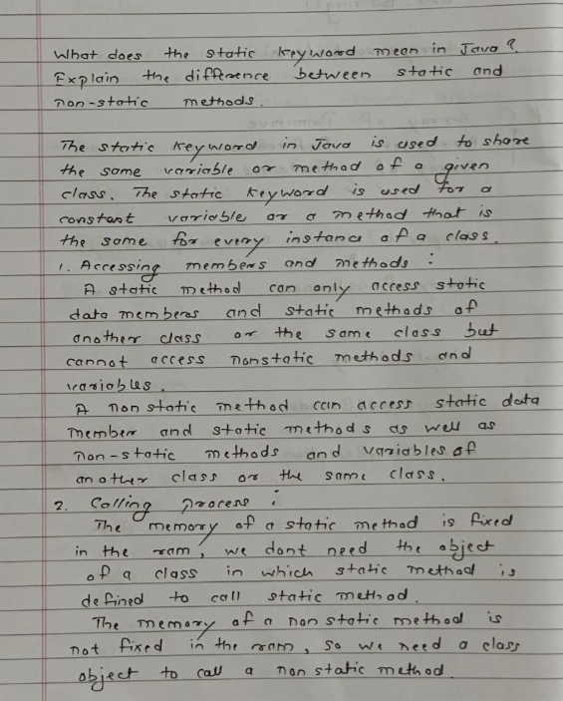

1. What is the role of the static keyword in the context of memory management.A piece of paper with writing on it

   Description automatically generated
2. Can static methods be overloaded and overridden in Java? How static variables shared across multiple instances of a class?

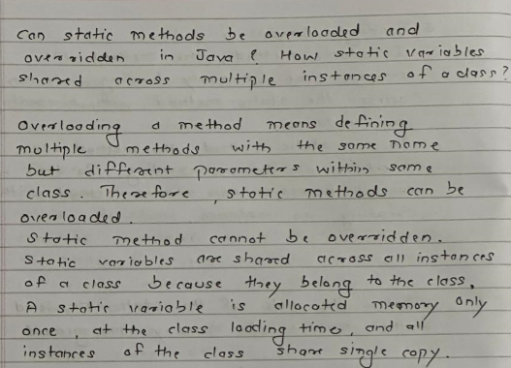

1. What is the significance of the final keyword in Java?

1. What are narrowing and widening conversions in Java?

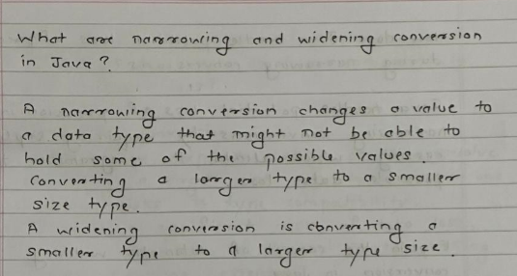

1. Provide examples of narrowing and widening conversions between primitive data types.

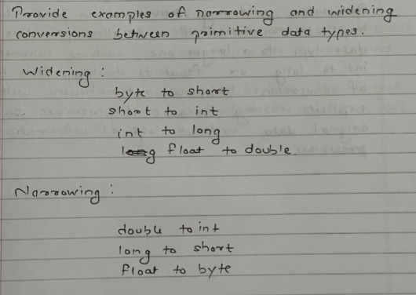

1. How does Java handle potential loss of precision during narrowing conversions?

1. Explain the concept of automatic widening conversion in Java.

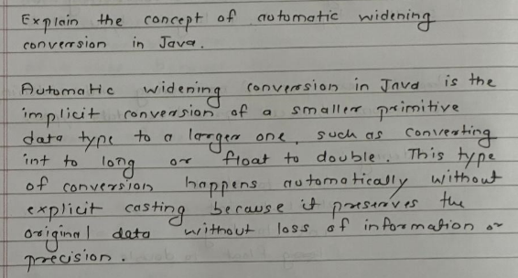

1. What are the implications of narrowing and widening conversions on type compatibility and data loss?

